Level Transmitter

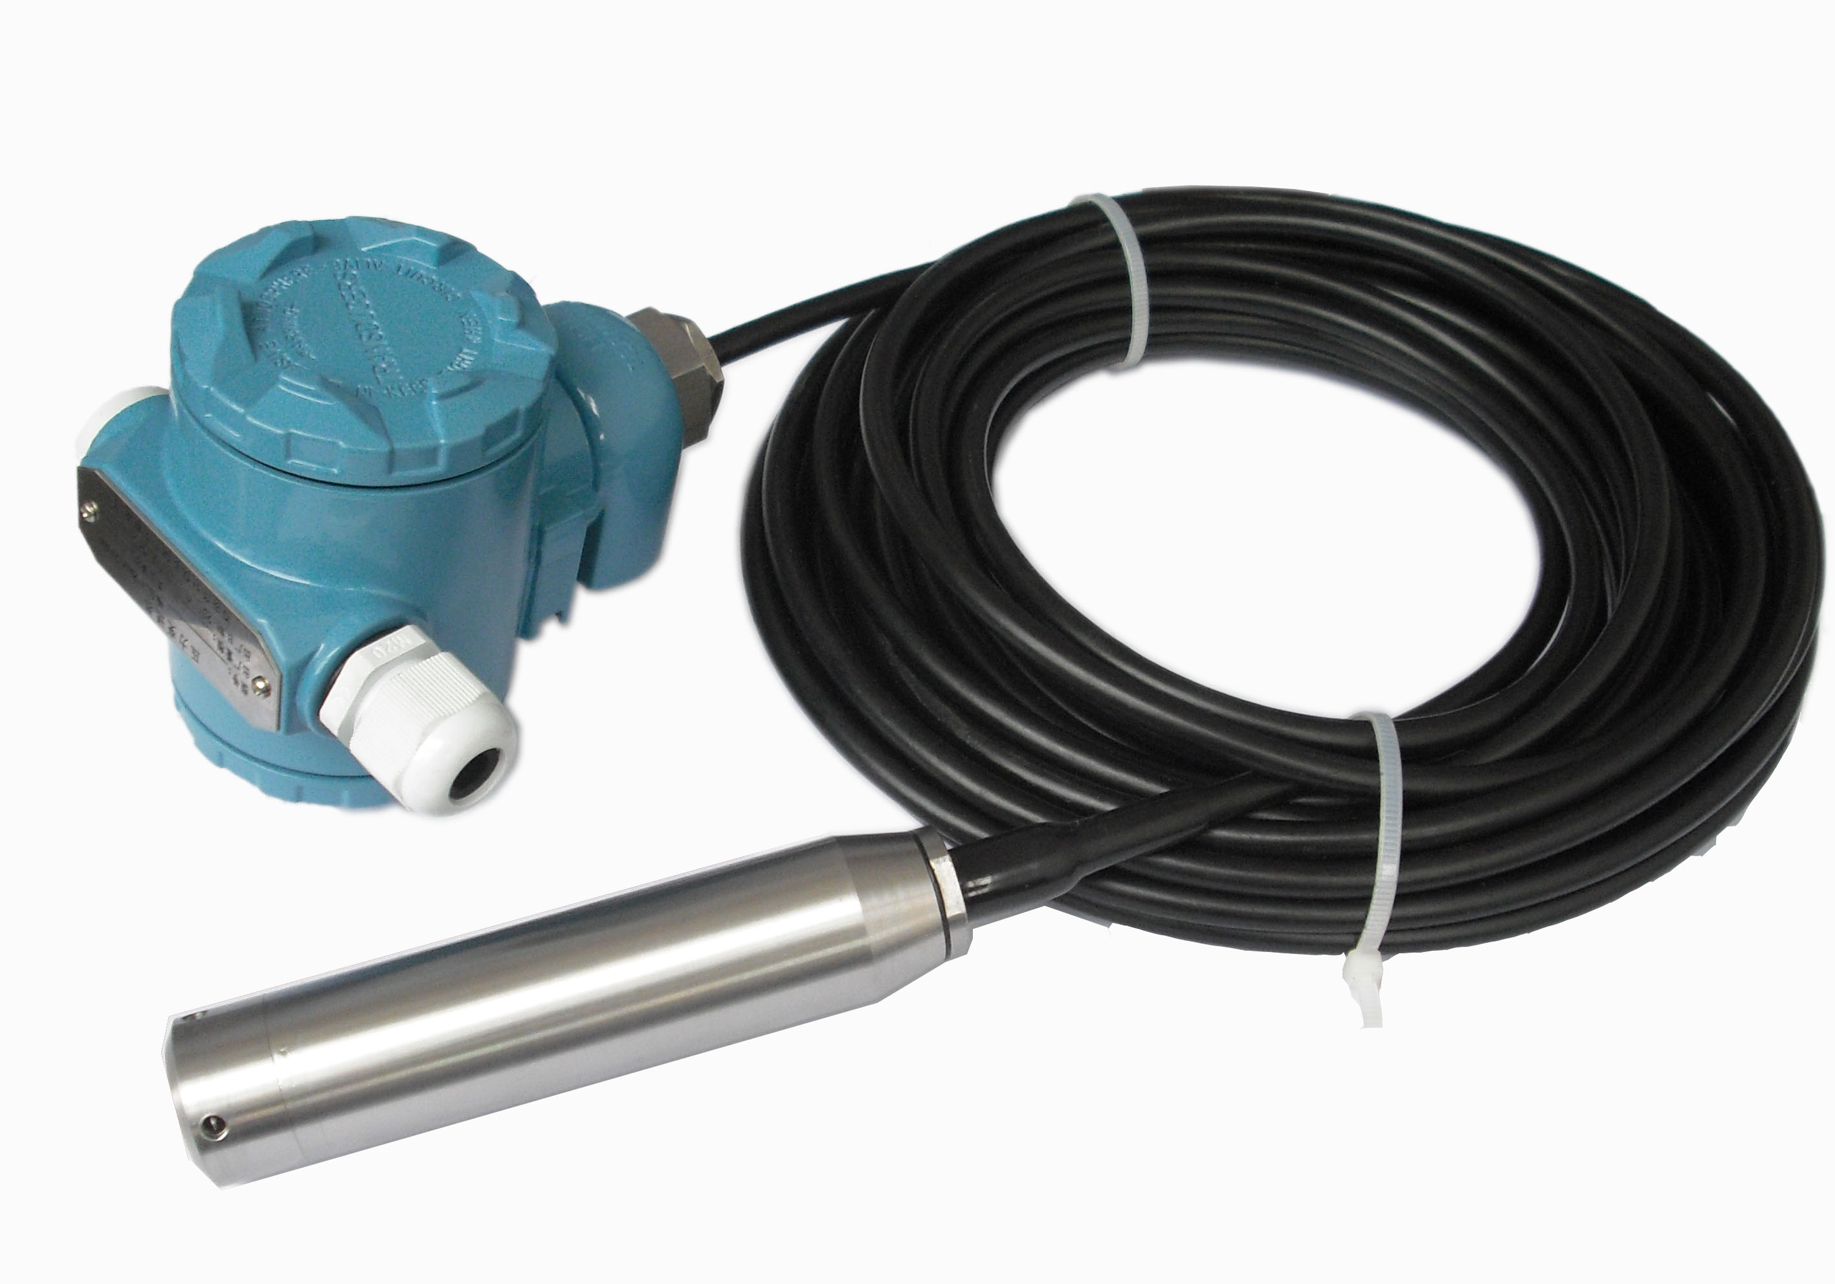

Manual

.
1.Summary
Liquid level transmitter, with the imported sensor and the temperature compensation of the computer laser, the integrated wiring box is used. With special terminal and digital display, installation, calibration, maintenance convenience.
This series of products are adapted to the oil, water conservancy, chemical, metallurgy, electric power, light industry, scientific research, environmental protection and other enterprises and institutions, to achieve the measurement of liquid level height and suitable for all kinds of weather conditions and all kinds of corrosive fluid.

2.Features
*Wide range selection;
*Digital pressure display;
*Zero point, range adjustment flexible
*Reverse polarity protection and current limiting protection
*Anti shock, safety and explosion proof
*Small size, beautiful appearance, cost-effective
*High precision, high stability, high reliability.

- Specifications

Range ：0~0.3...100m
Output signal：4～20mA
Voltage：18～36VDC
Precision： 0.25,0.5%
Overload：150%
Temperature：-40℃～80℃
Stability：≤±0.2%FS/year
Protection：IP67
Sealed material: Nitrile/Fluoride rubber
Pressure connection: 1Cr18Ni9Ti
Sensor diaphragm：SS316L

4.Dimension

- 5.Electrical connection
-
-
-
-
-
-
OUT
TEST
2088 diagram
2 wires 4～20mA
OUT+
OUT―
V +
SENSOR
TEST+
TEST―
V－
SDF DSAF

Signal wire can use the double strand. We recommend the shielded wire in the situation with serious electromagnetic interference and please properly connect the wire to the ground .Don’t put the signal cables into a metal tube with other power cables or put them in the same slot, and decorate the wire far away from strong electric facilities.

